CHALLENGES ON VPC
- Design and deploy a scalable network architecture using AWS Transit Gateway to simplify network connectivity between multiple VPCs.
1. Create a central Transit Gateway
This TGW becomes the core routing hub for the entire organization.
All VPCs will attach to this TGW instead of peering with each other.
2. Attach all VPCs to the Transit Gateway
Each department’s VPC—Finance, HR, Development, Operations—creates a TGW VPC attachment, linking its private subnets to the TGW.
3. Configure TGW route tables
Routing is controlled centrally using Transit Gateway route tables.
You define which VPCs can talk to each other:
- Full mesh (all VPCs communicate)
- Hub-and-spoke (spokes communicate only with shared services VPC)
- Limited communication (security boundaries)
This gives the organization complete control over traffic flow.
4. Update VPC route tables
Each VPC’s subnet route table adds routes pointing to the TGW for all other VPC CIDRs.
VPCs no longer need direct VPC peering links.
5. Result: Simple, scalable, centralized routing
Transit Gateway simplifies the network design by reducing dozens of VPC peering connections into one connection per VPC.

Step 1: Create Transit Gateway
- Navigate to Transit Gateway and click on Create transit gateways
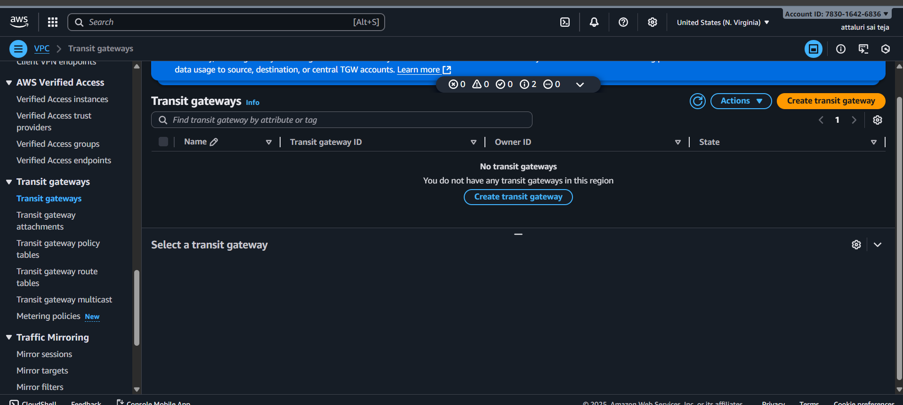
A transit gateway (TGW) is a network transit hub that interconnects attachments (VPCs and VPNs) within the same AWS account or across AWS accounts.
- Now click on create Transit Gateway
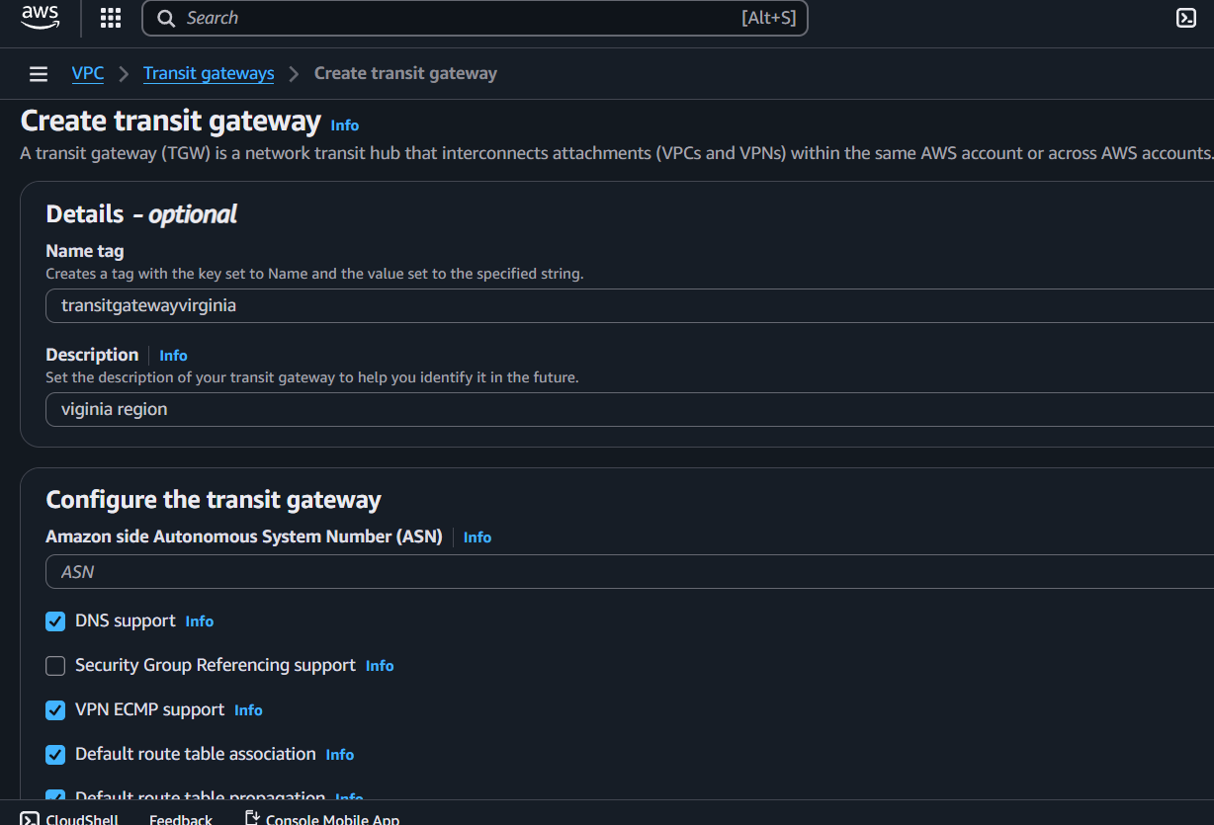

- Here we see transit gateway successfully created
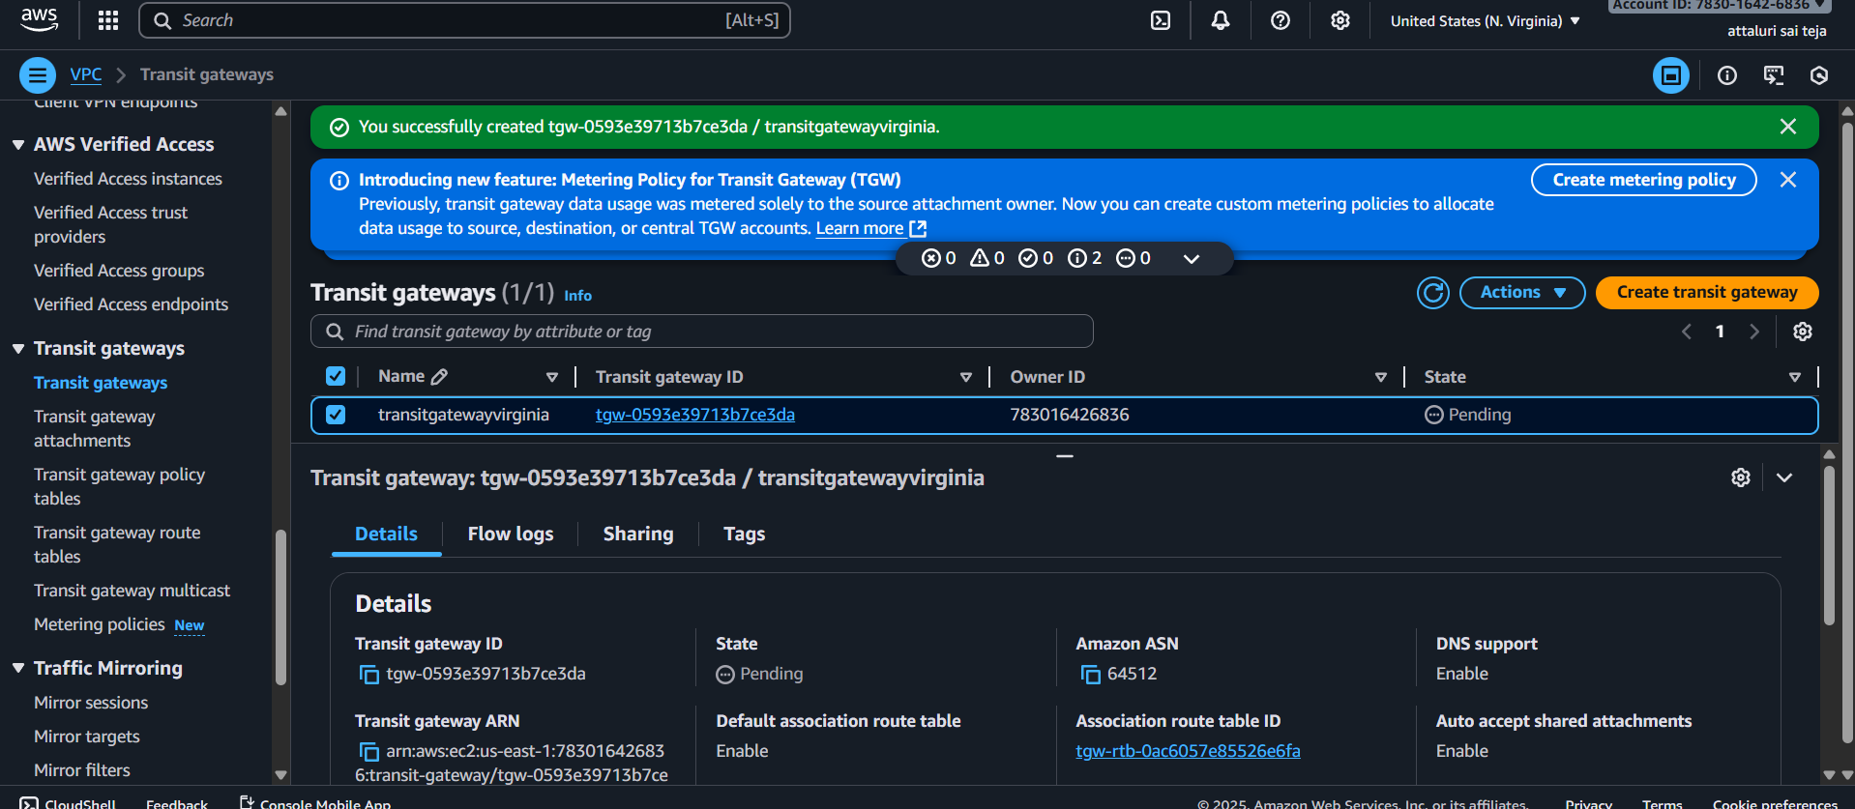
Step 2: Configuring VPCs
- Now create four VPCs or select existing VPCs.
- Navigate to VPC Dashboard and click on create vpc
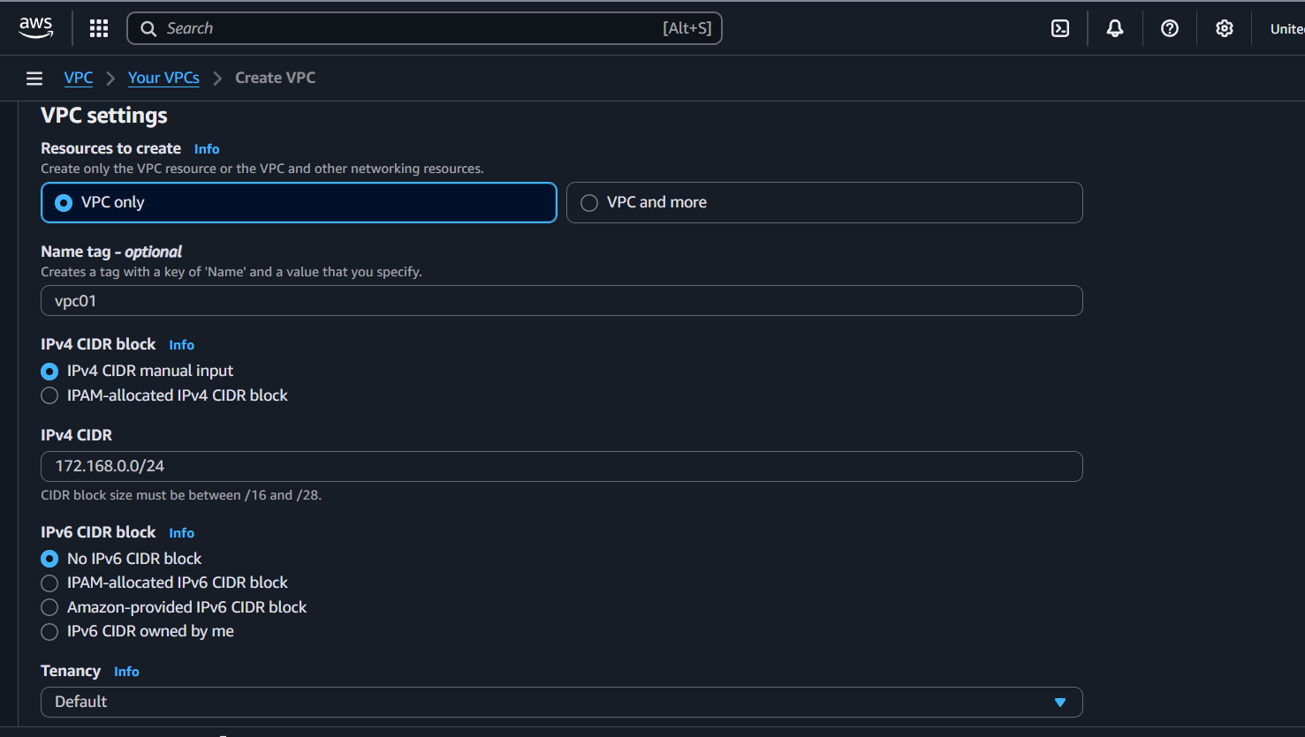

- Same process do for VPC2, VPC3 and VPC4.
- Here we see two VPC are created.
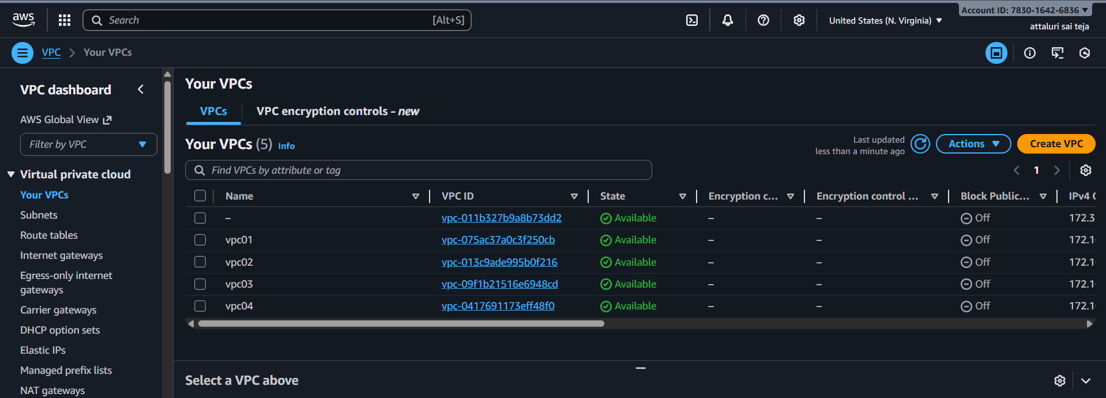
Step 3: create subnets
- Navigate to subnet section in vpc and click on create
- Do the same for each vpc
- We get around 4 subnets 1 for each
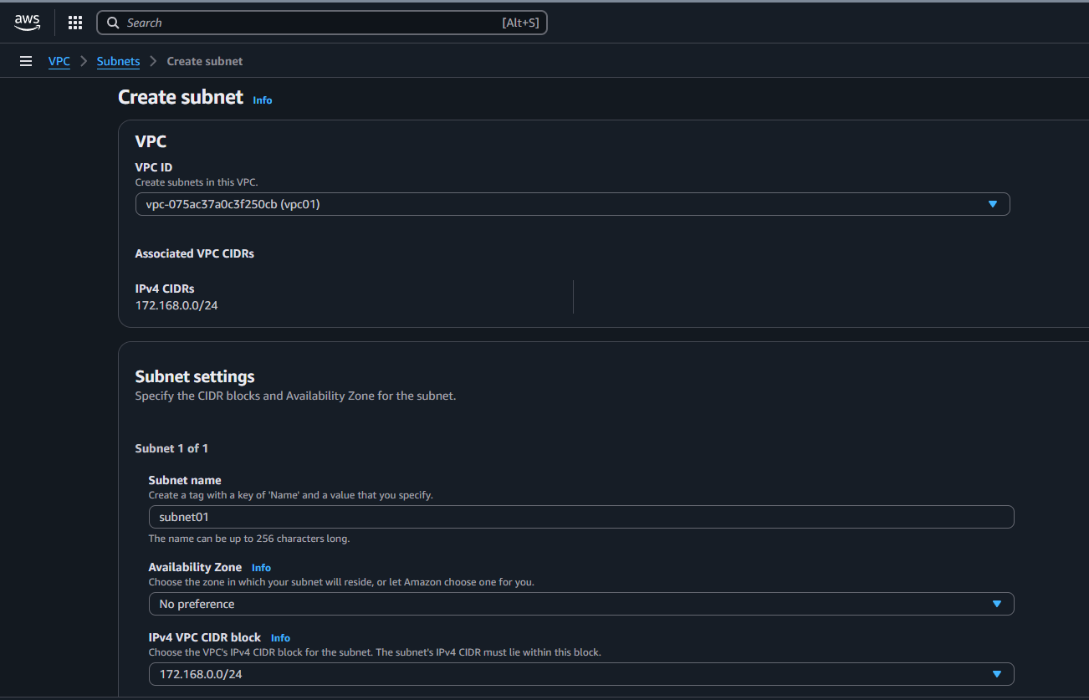

- Subnets have been created
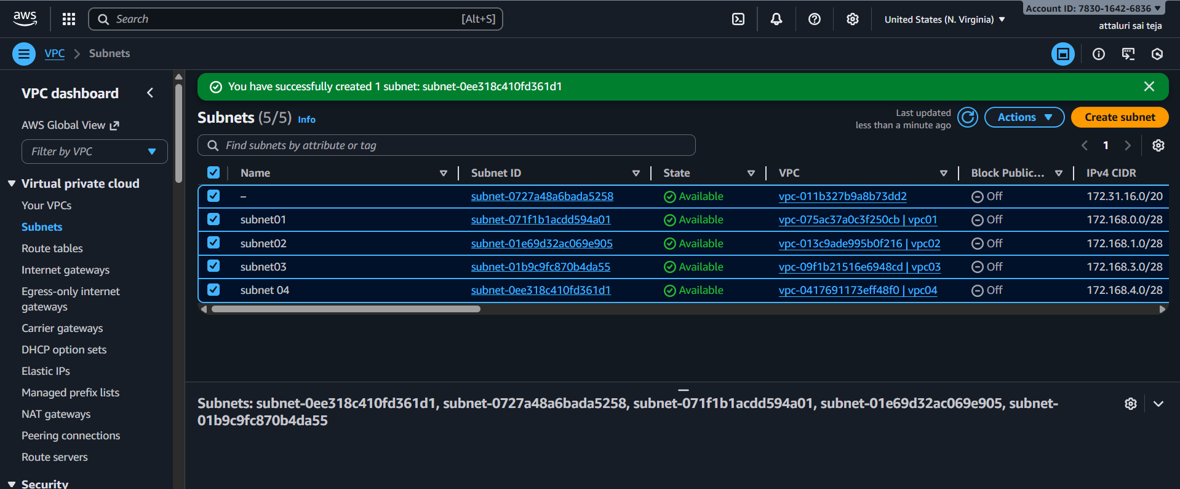

- Also create a Public subnet with VPC 02
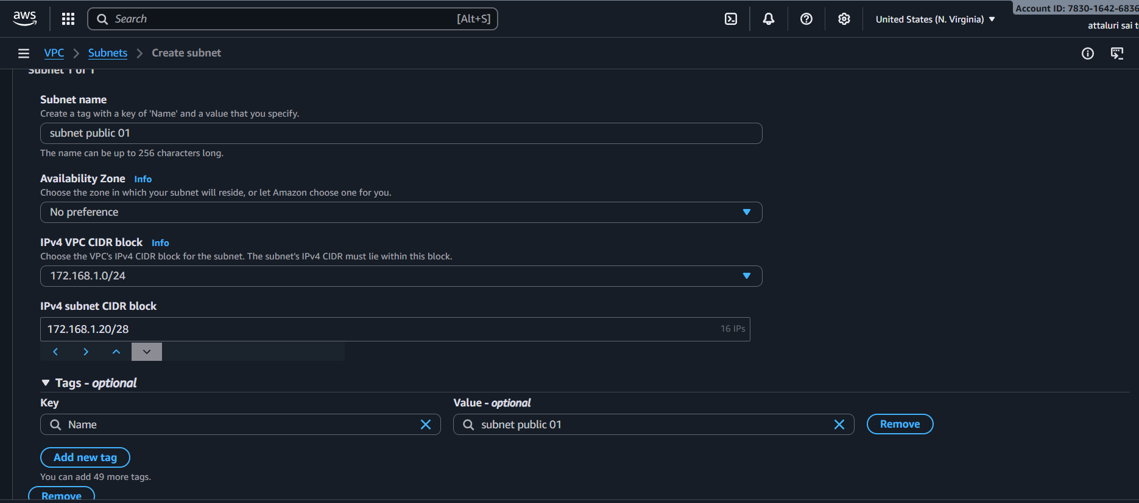
- Public Subnet Has been created
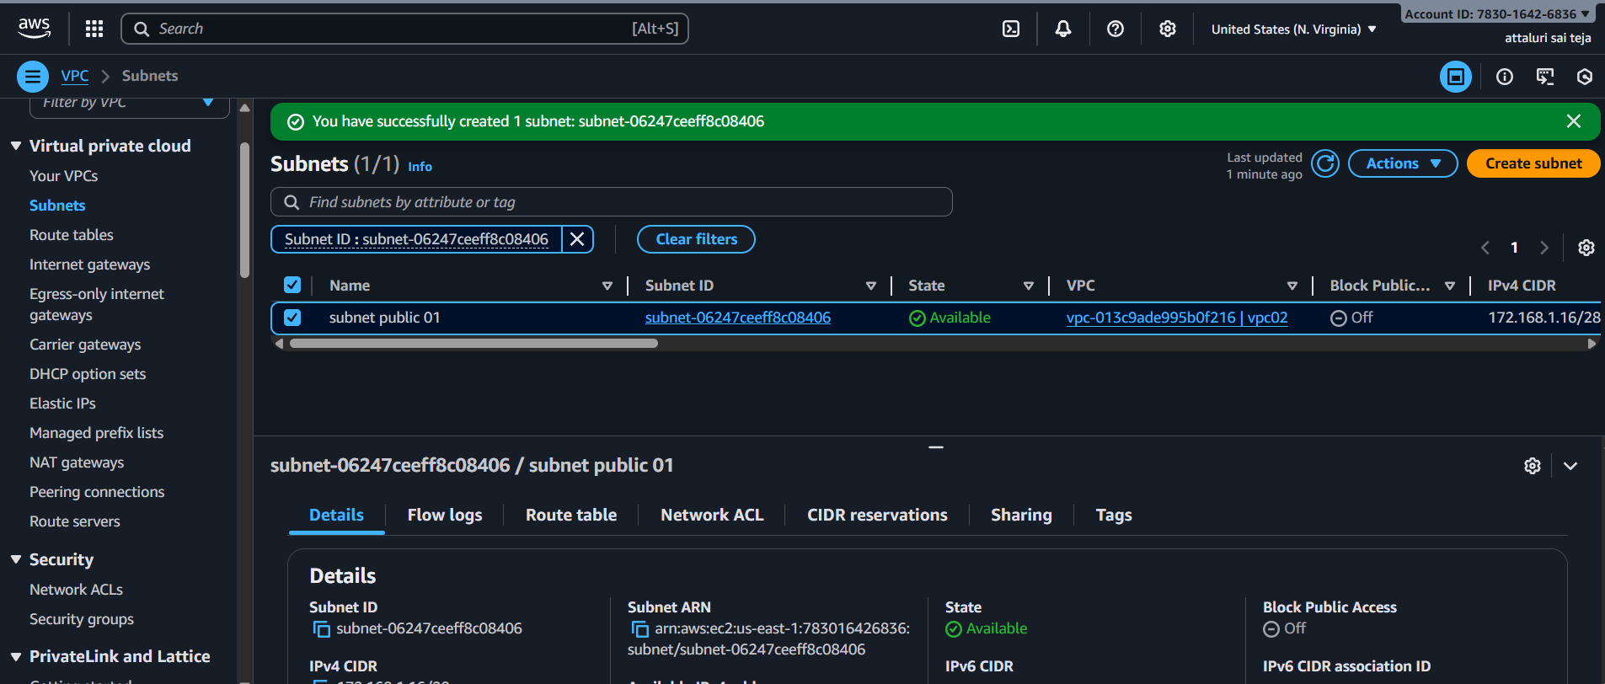
Step 4: create IGW
- Navigate to Internet Gateway Section and click on create internet gateway option
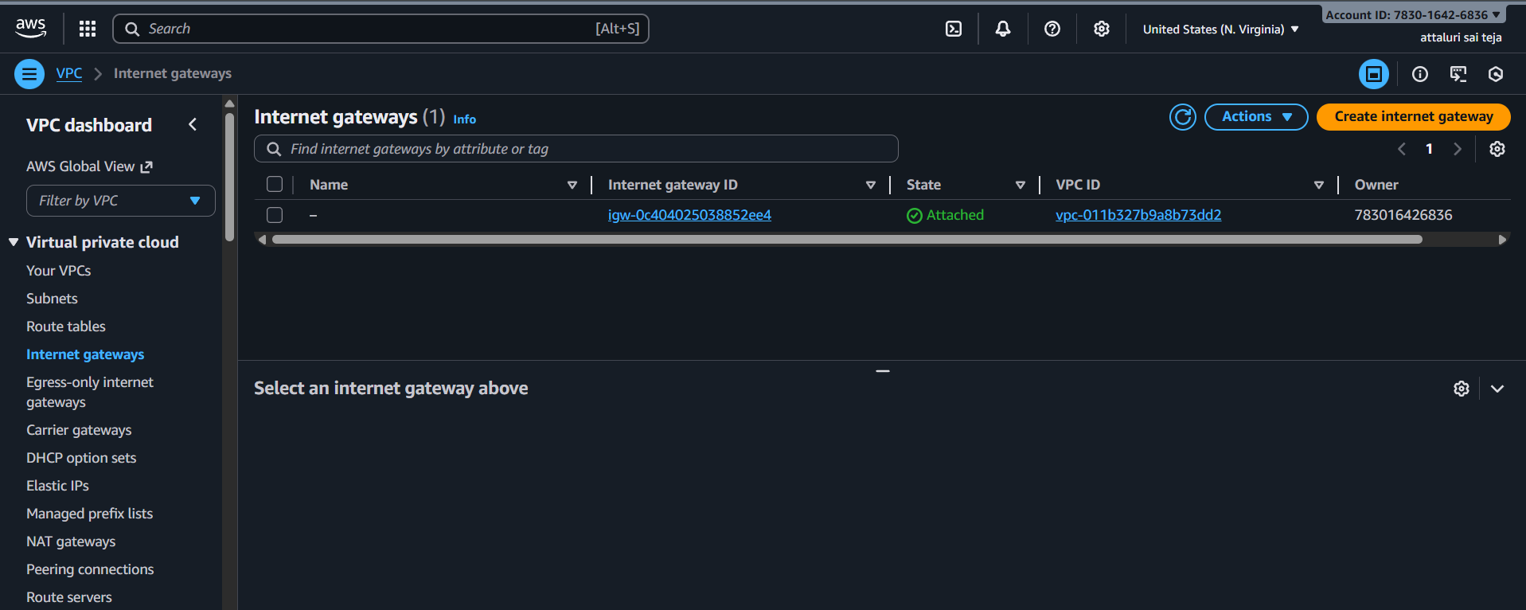
- Igw has been created
- Attach it to VPC 02
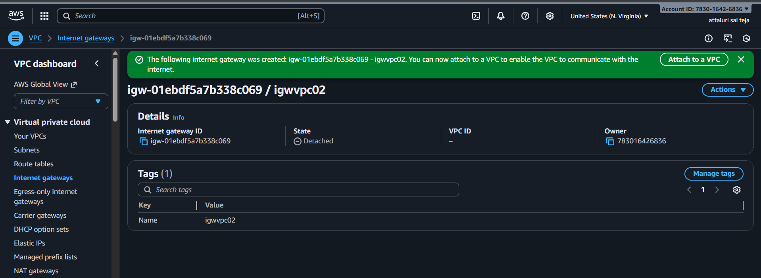
- Selected the vpc 02 and attached the vpc to igw
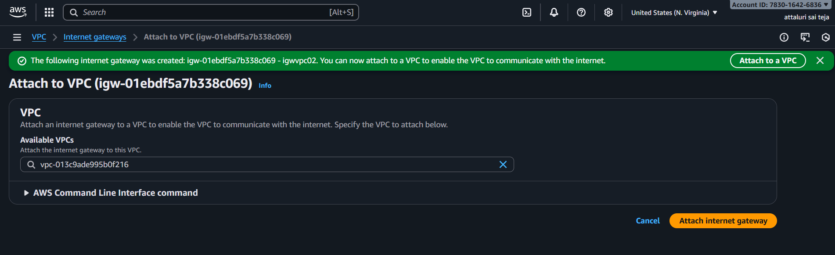
- Navigate to Routes table and select public route table and edit the route table
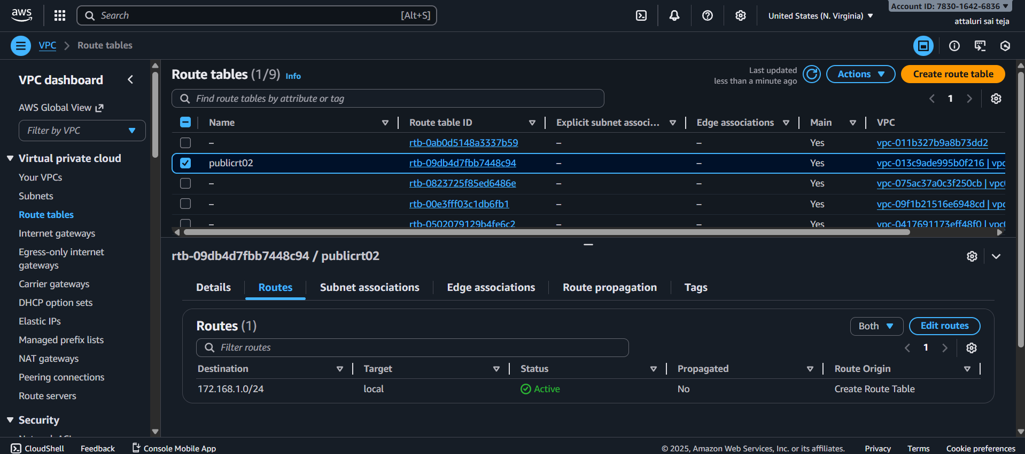
- Attach the igw into it
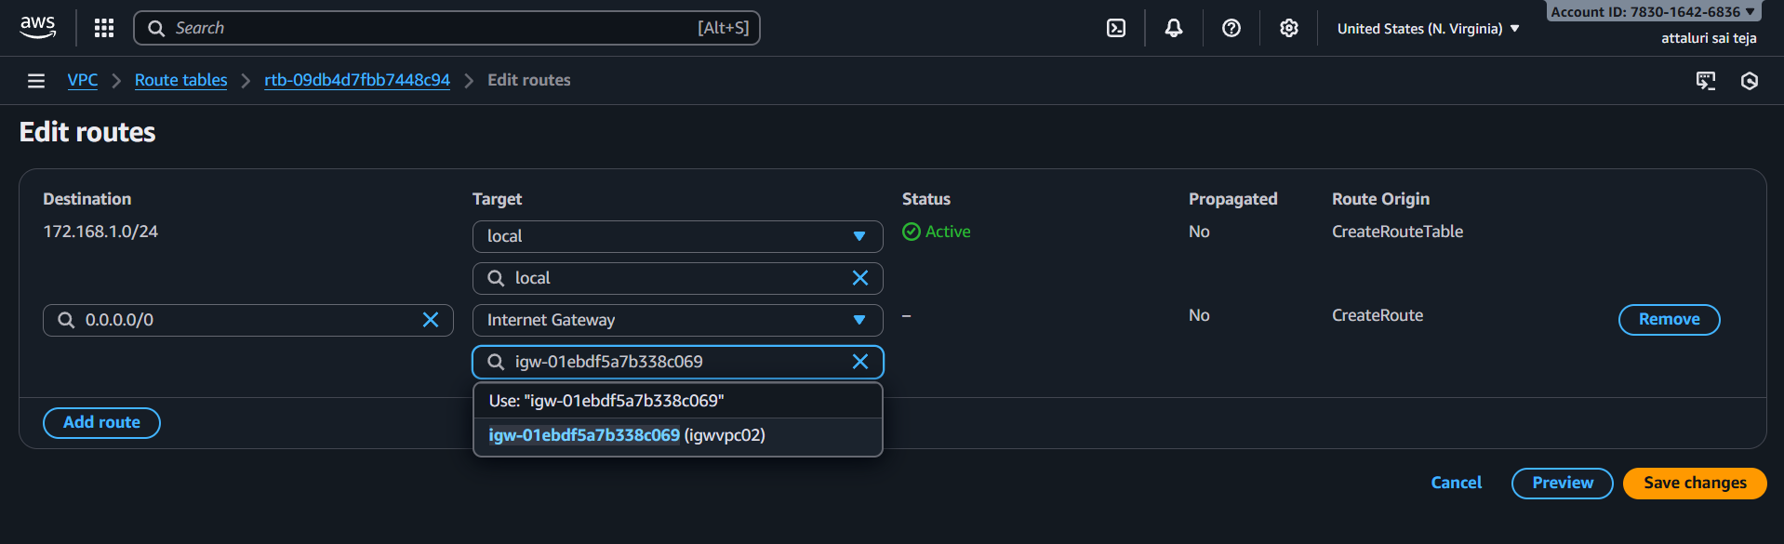
- Route Table has been updated
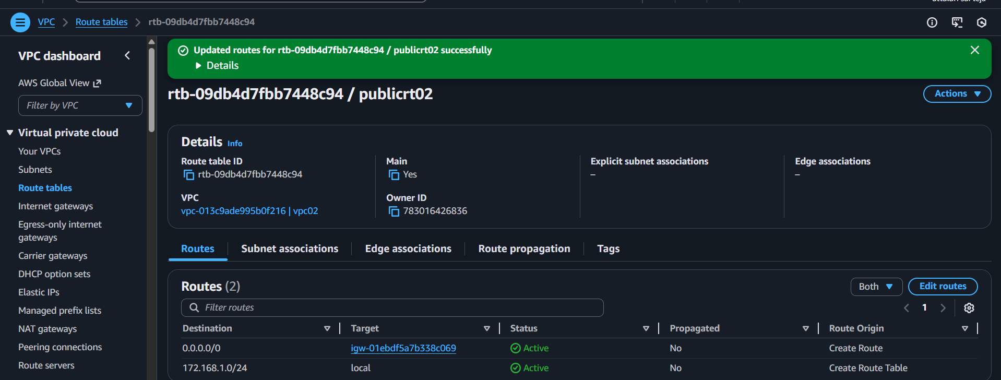

- Navigate to Subnet associations and attach public subnet
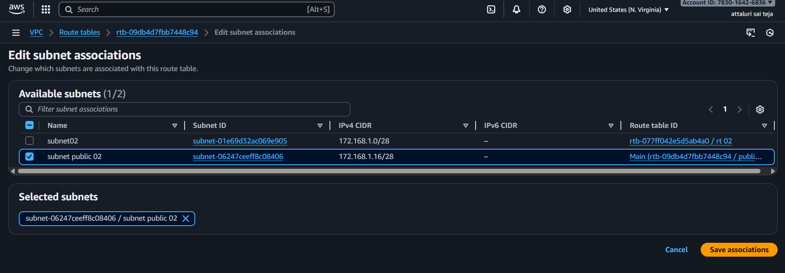
- Successfully Updated Subnet Associations
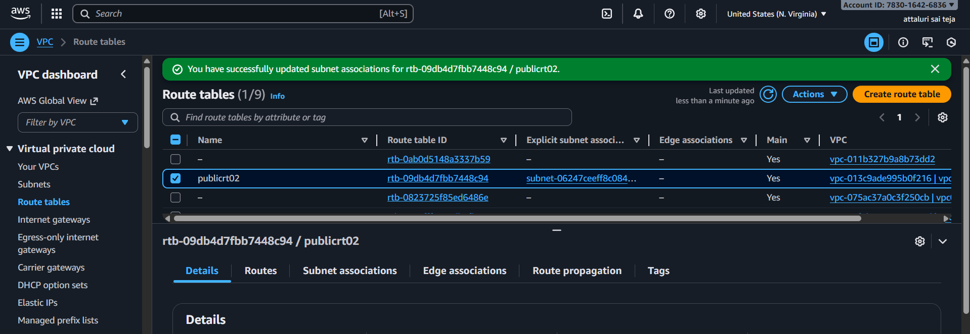
Step 5: Transit Gateway Attachments
- Now select Transit gateway ID which is created in previous step and next select attachment type vpc
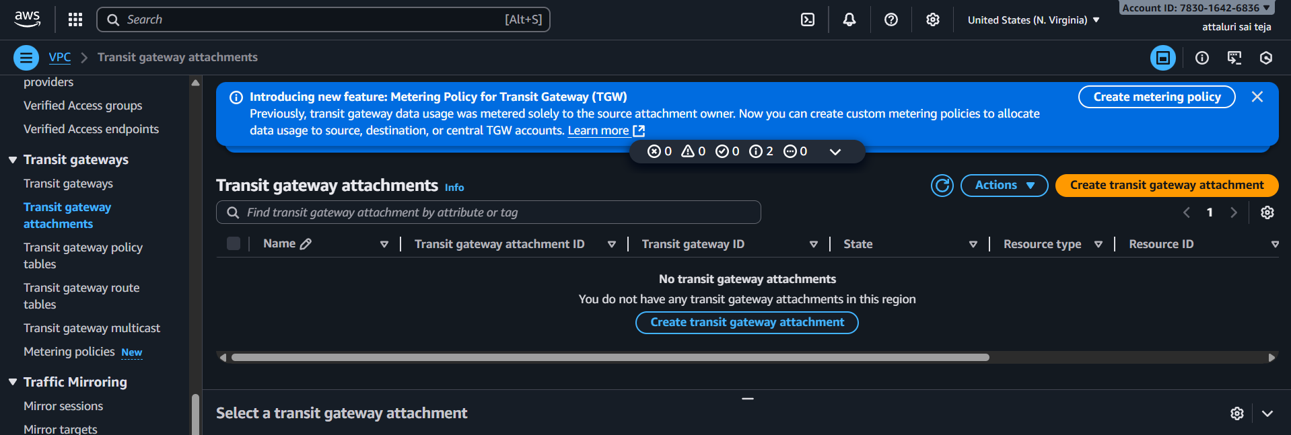
- VPC attachment: Select and configure your VPC attachment.
- VPC ID: Select the VPC1 to attach to the transit gateway.
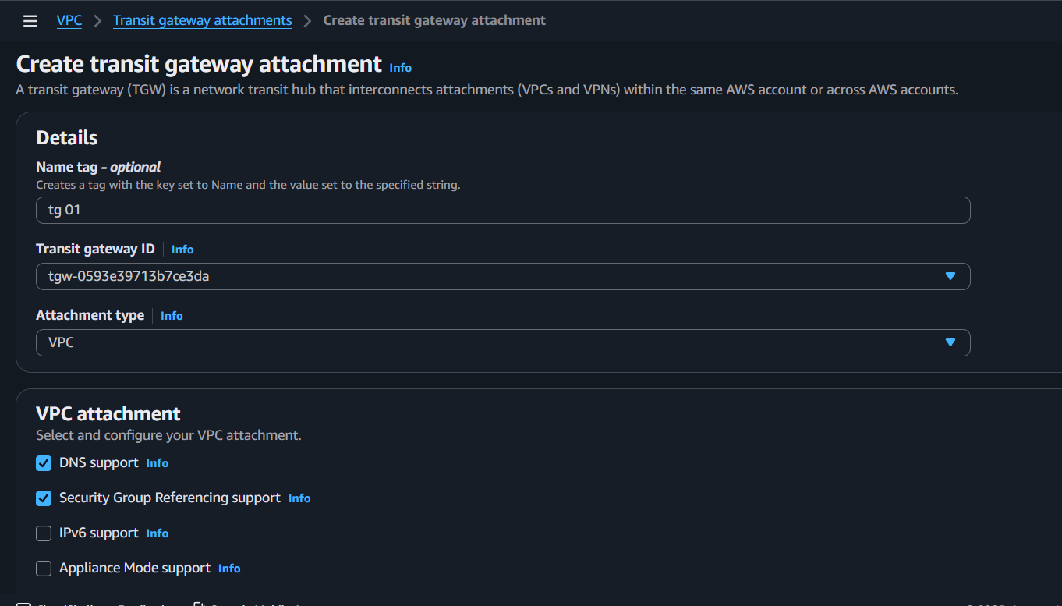
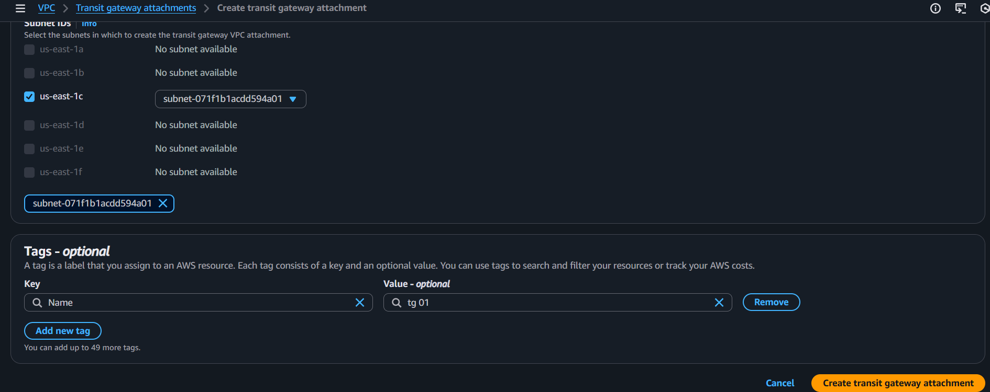
- Same we need to do on VPC2 as well.
- Here we see VPC1 and VPC2 are attached to transit gateway

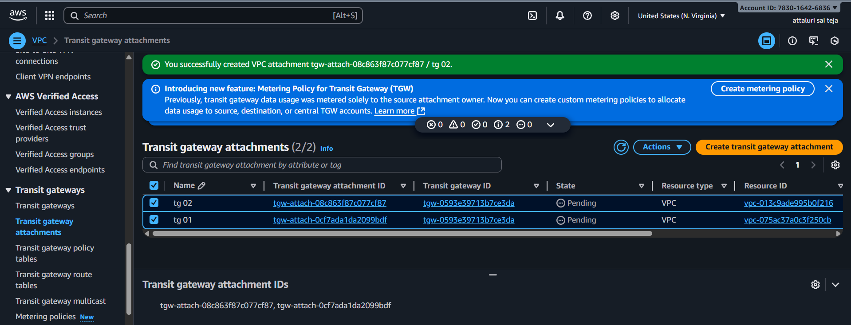

Step 6: Creating route Tables
- Navigate to route table section and create route table 1 for each vpc
- Click on create route table
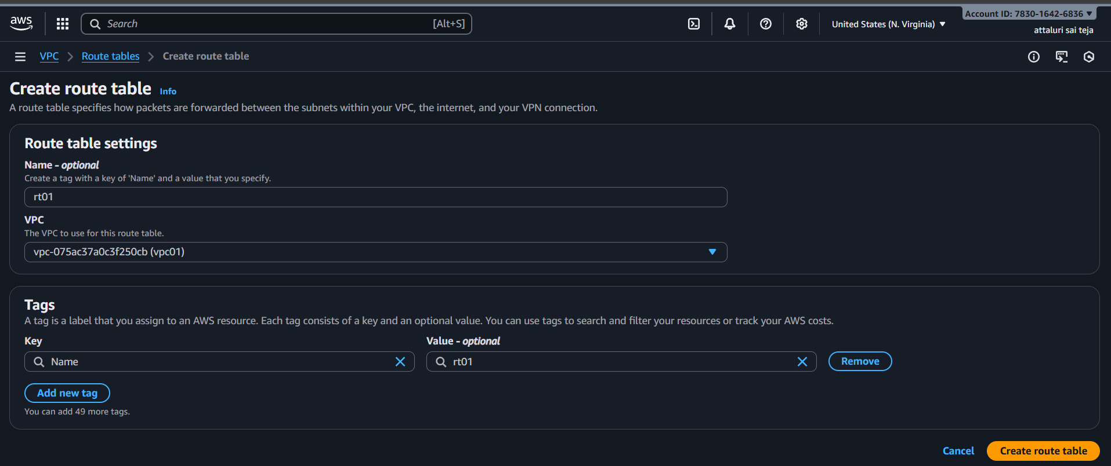
- Do the same for vpc2, vpc3 , vpc4
- Route table has been configured for each
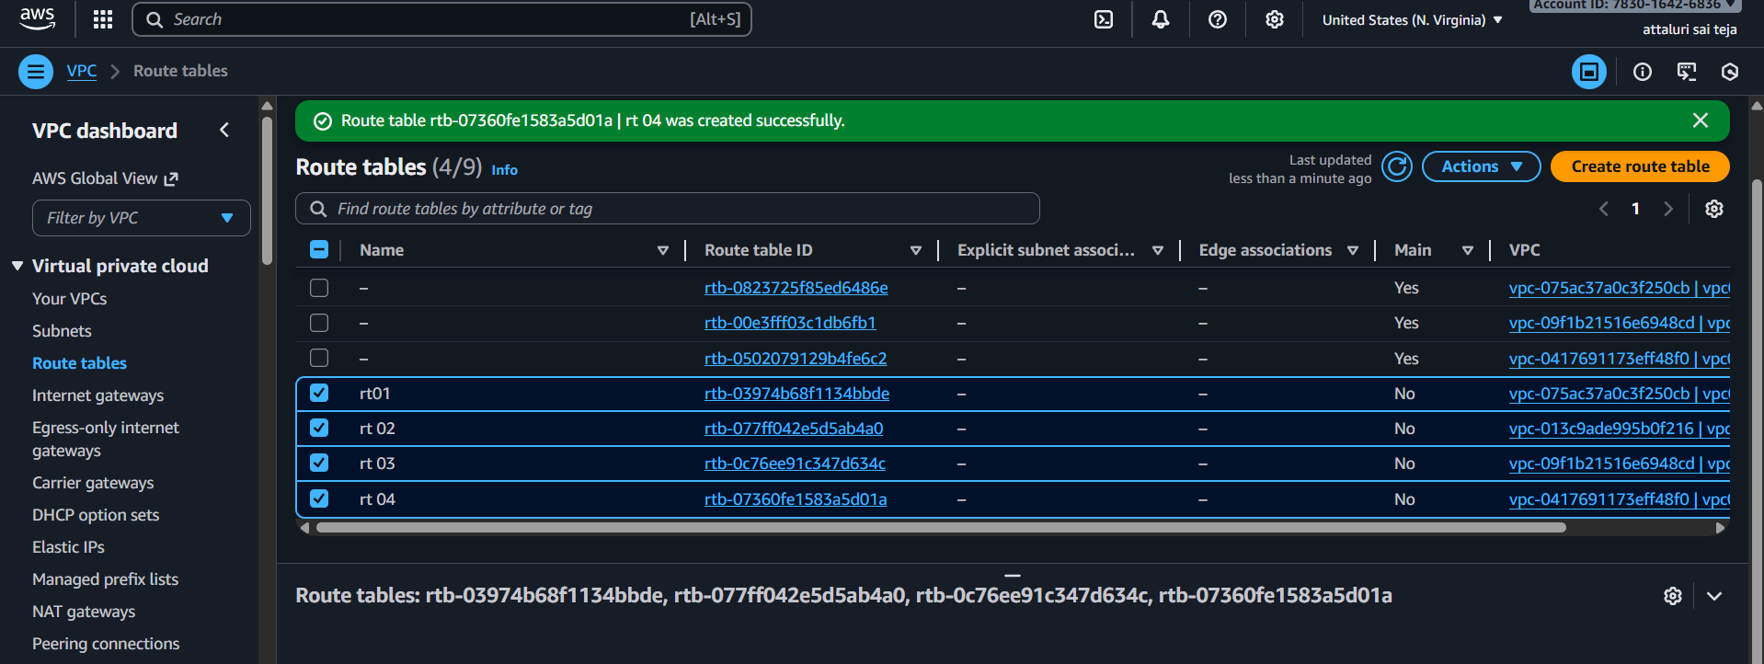

Step 7: Adding subnet associations in route table
- Navigate to route table and select subnet association tab and add each subnet association for each route
- Click on save association
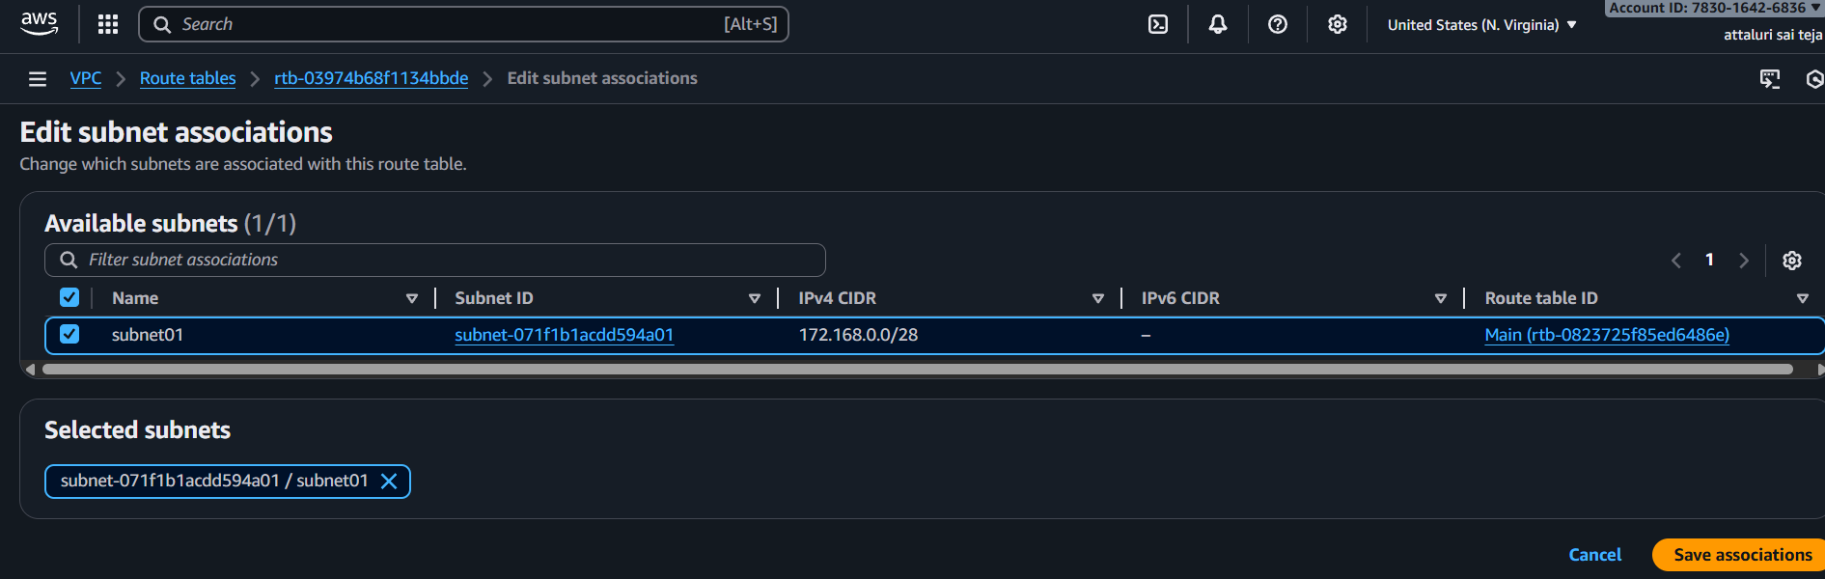
- Do the same for all vpc,s
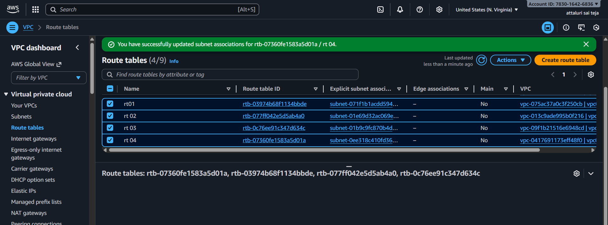
- Now choose route table and navigate to routes
- Click on Edit route and choose add route
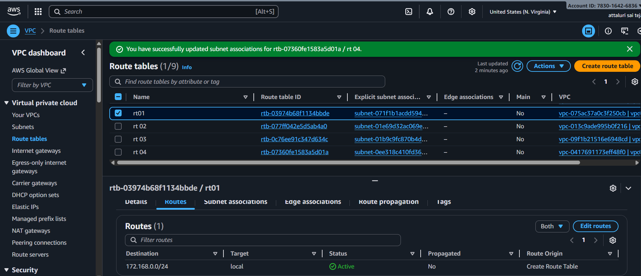
- Set CIDR block and in drop down box select Transit gateway and click save changes
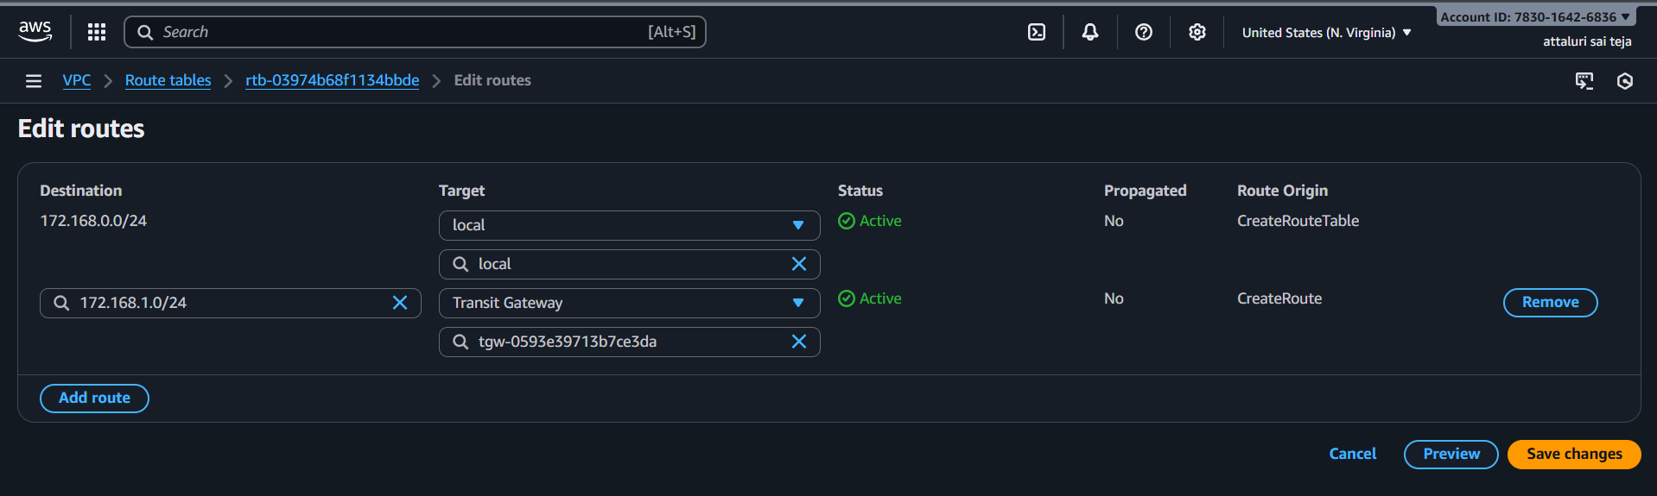
- Route table was updated
- Now same process we need to do for the VPC2 as well.
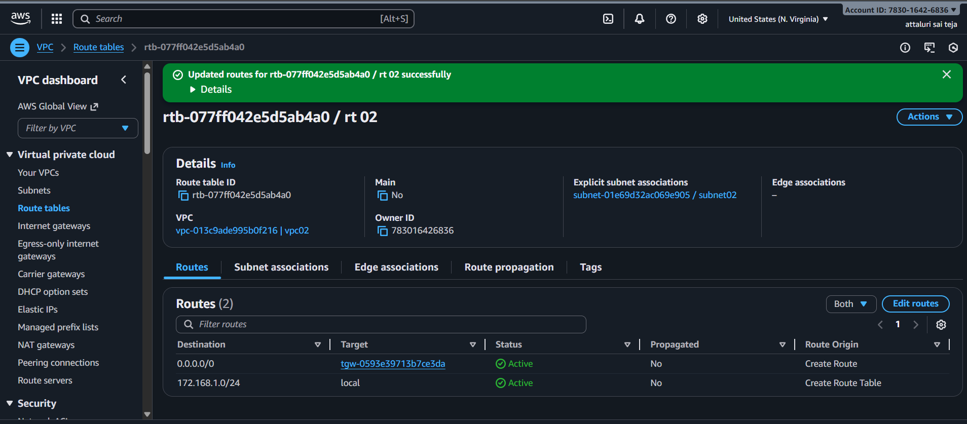
Step 8: Configuring security groups
- Create New Security Groups or select existing security group
- Now edit inbound rules to security groups allow all traffic
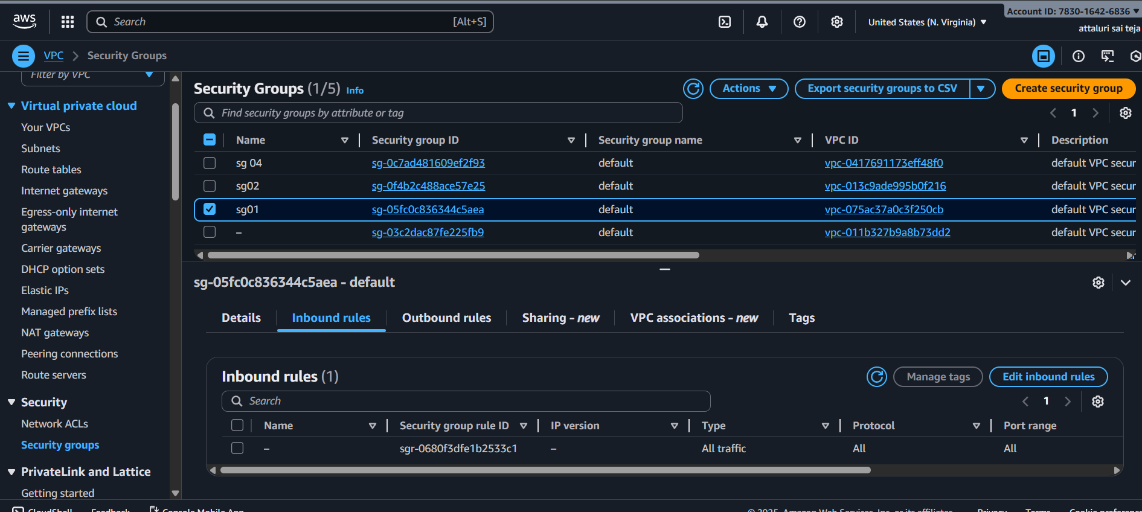
Step 9: Launch EC2 Instance
- While launching instances in network settings choose created VPCs and also choose private subnet as shown in below figure
Instance -01
- Launce the instance from the vpc one with the Private Subnet
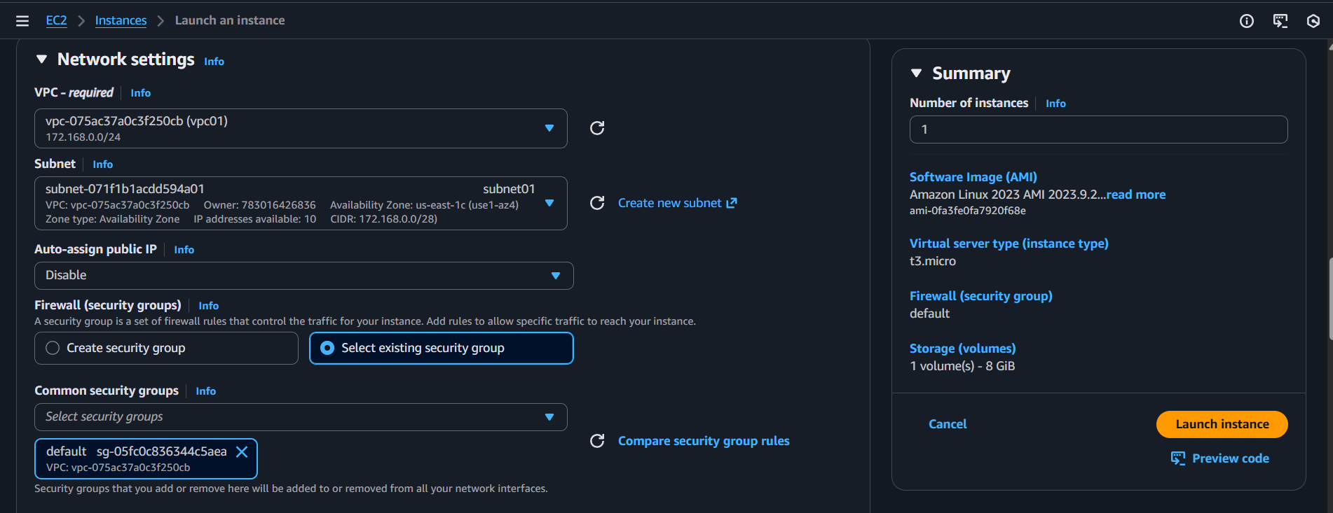
Instance -2
Launce the instance from the VPC two with the public subnet.
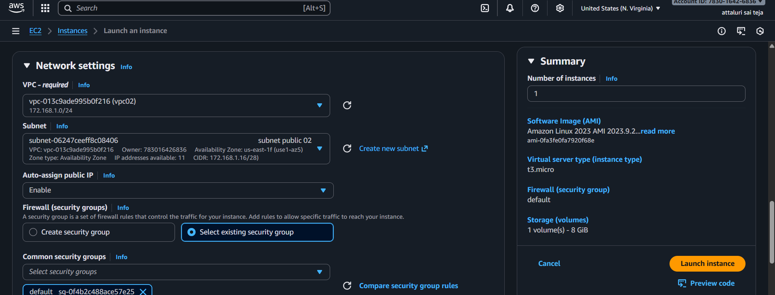
- Both EC2 has been Launched
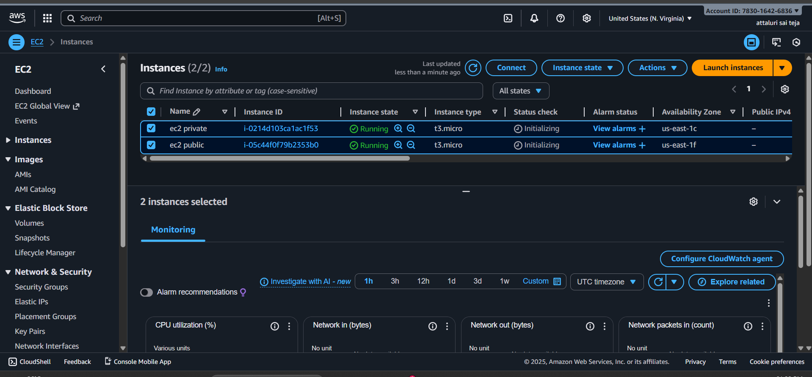
Now both EC2 instances in their respective VPCs are created.,
That is VPC1 and VPC2. They can communicate to each other with their private IPs through transit gateway
Step 10: Connect ec2 instance
- Connect Through Public Instance
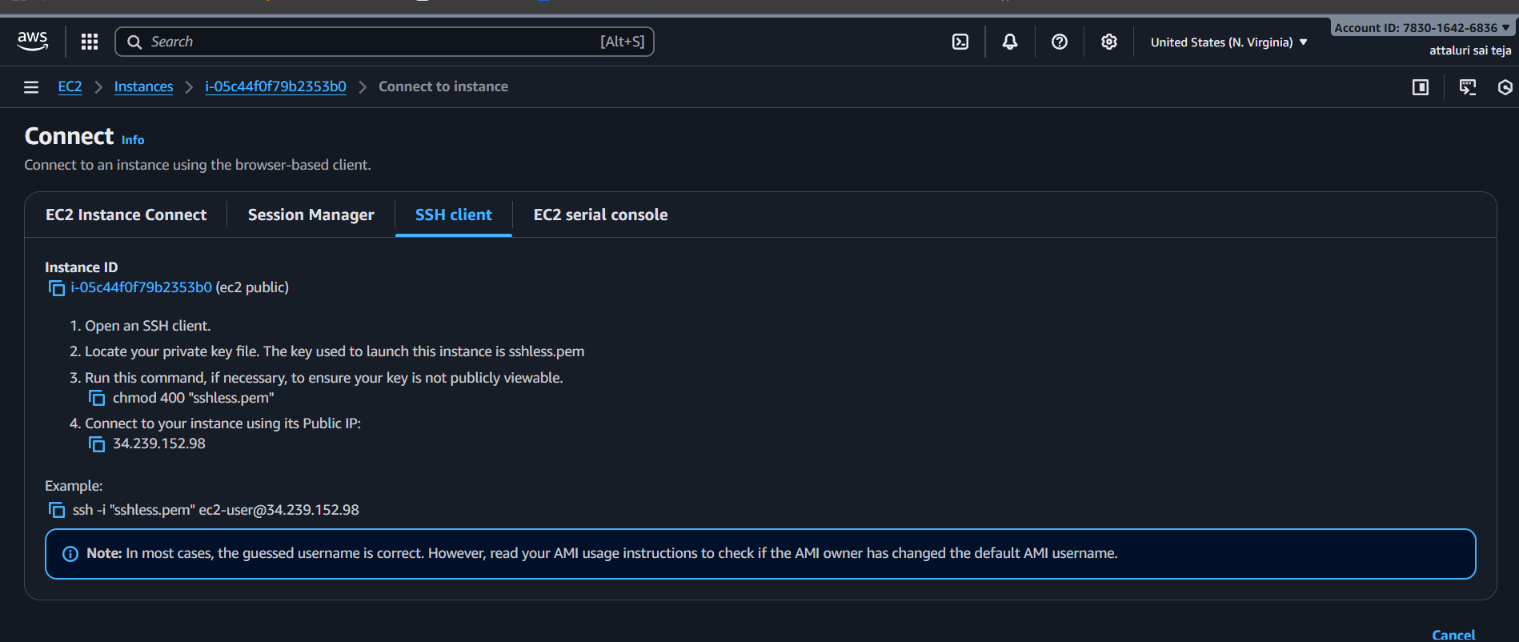
- Connected with Public Instance
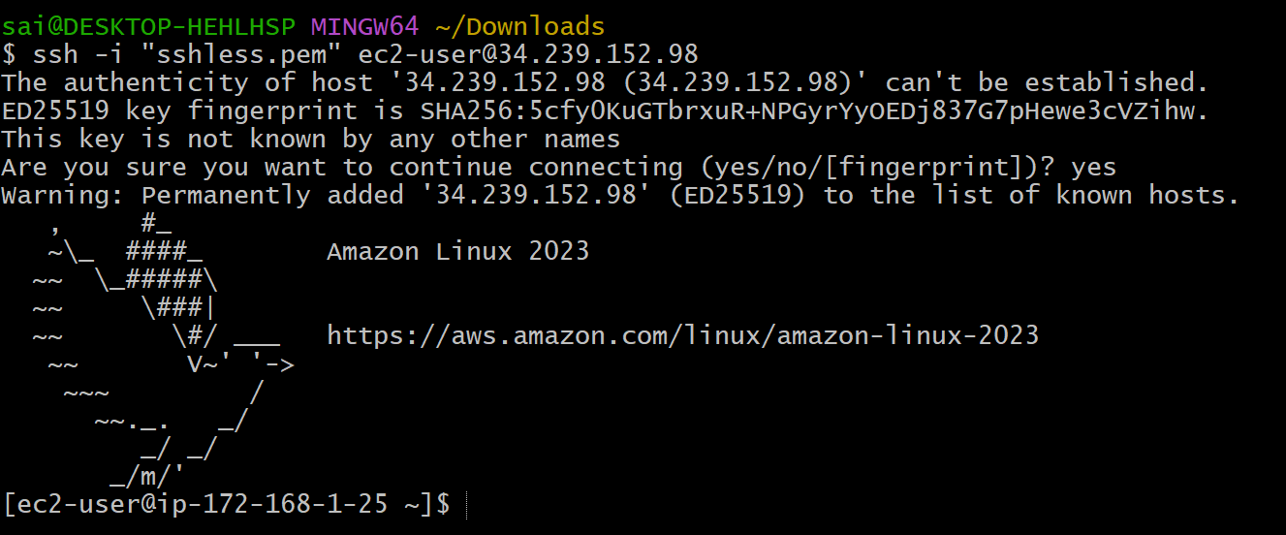
- Now securely copy the keypair .pem file to the desired path in the EC2 instance of VPC 1:
- And verified using ping@privateip of another instance

Here we see VPC 1 to VPC 2
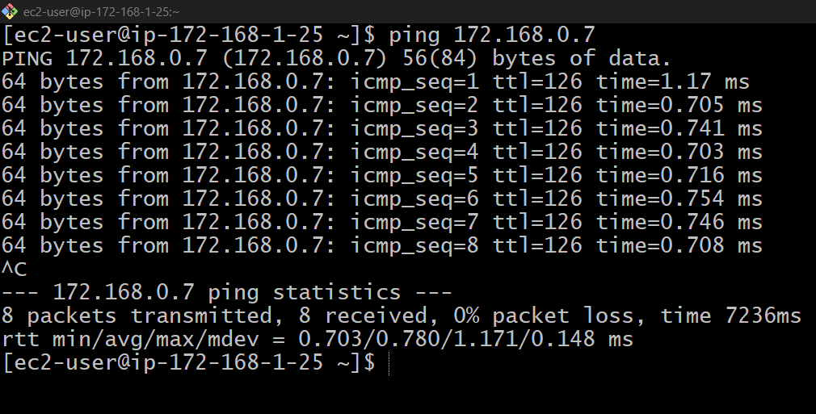
- Do the same process another vpc’s .
Here we see VPC 2 to VPC 1 and VPC3
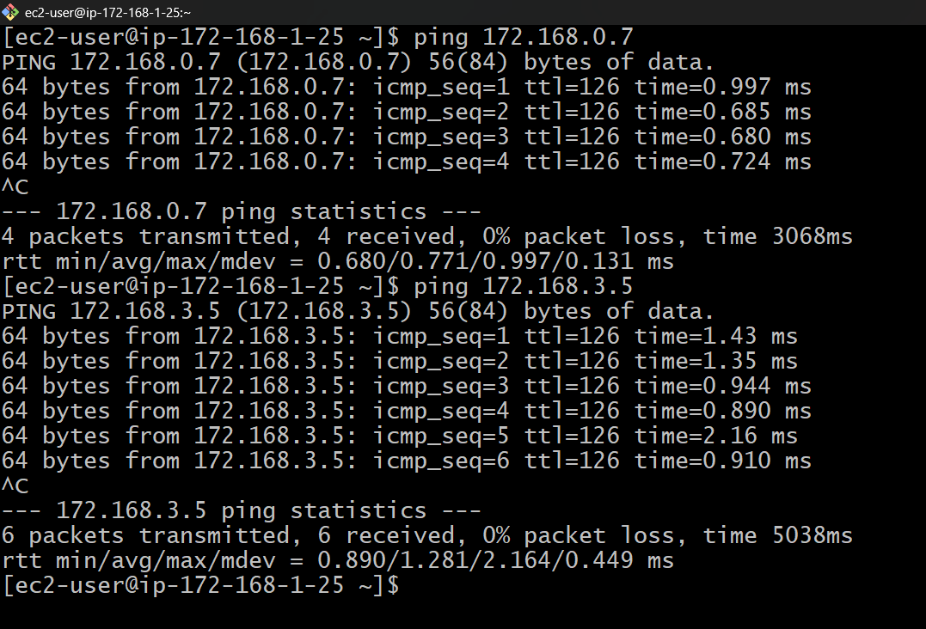

- Adding route table screen shots for reference
- Main vpc
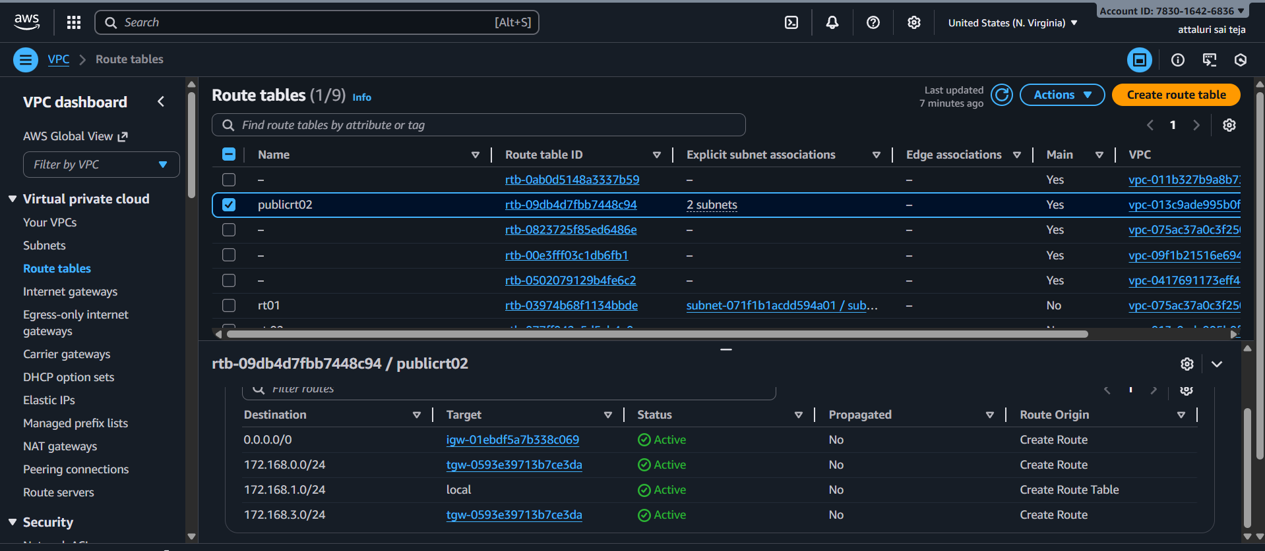
Vpc 03 route table
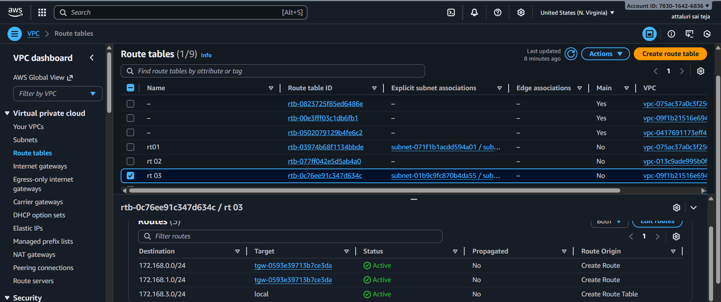

Security group of vpc 03 for reference
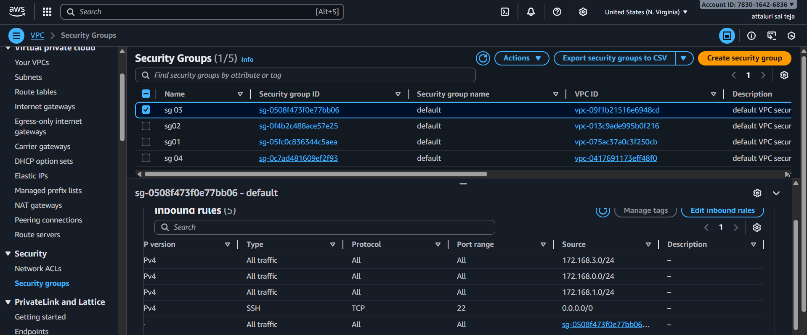
AWS Transit Gateway (TGW) is a central router provided by AWS.
It allows you to connect multiple VPCs, VPNs, on-prem networks, all in a scalable way

2 . Configure VPC endpoints to securely access AWS services without internet gateways or NAT gateways, ensuring data privacy and minimizing exposure to external threats
VPC endpoints allow private workloads to securely access AWS services without using internet gateways or NAT gateways. They keep sensitive traffic inside AWS’s internal network, reducing exposure to external threats and ensuring strong security and compliance for multi-VPC architectures.
Step 1: Navigate to AWS VPC Dashboard
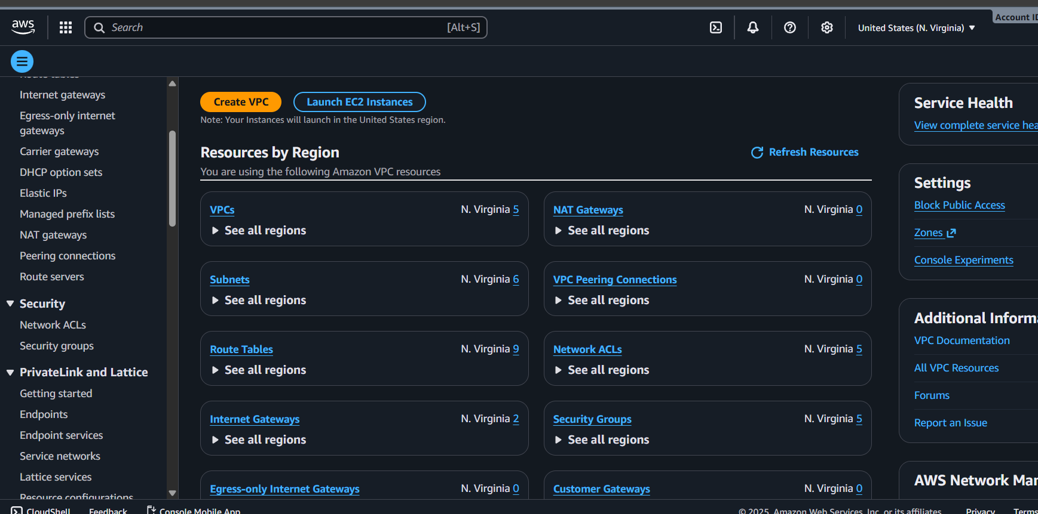
Step 2: Select Endpoints from the Navigation Panel
- In this VPC Dashboard, locate to the "Endpoints" option in the navigation pane.
- Choose the VPC Endpoints at the left panel. Click on Create Endpoint.
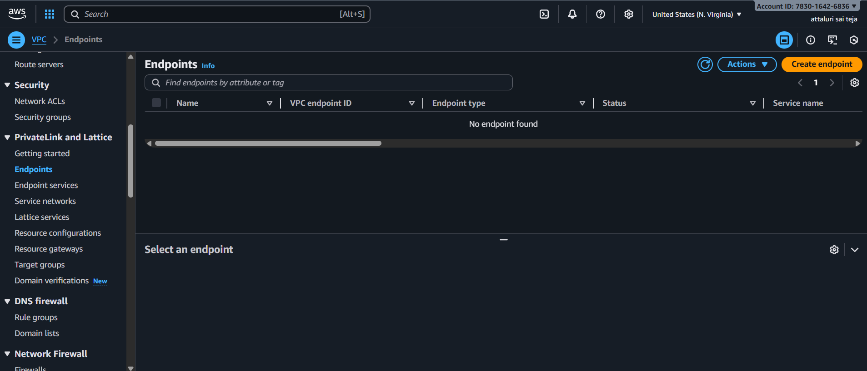

Step 4: Create Endpoint
- On Clicking on the create Endpoint button, it starts the creation process of endpoint.
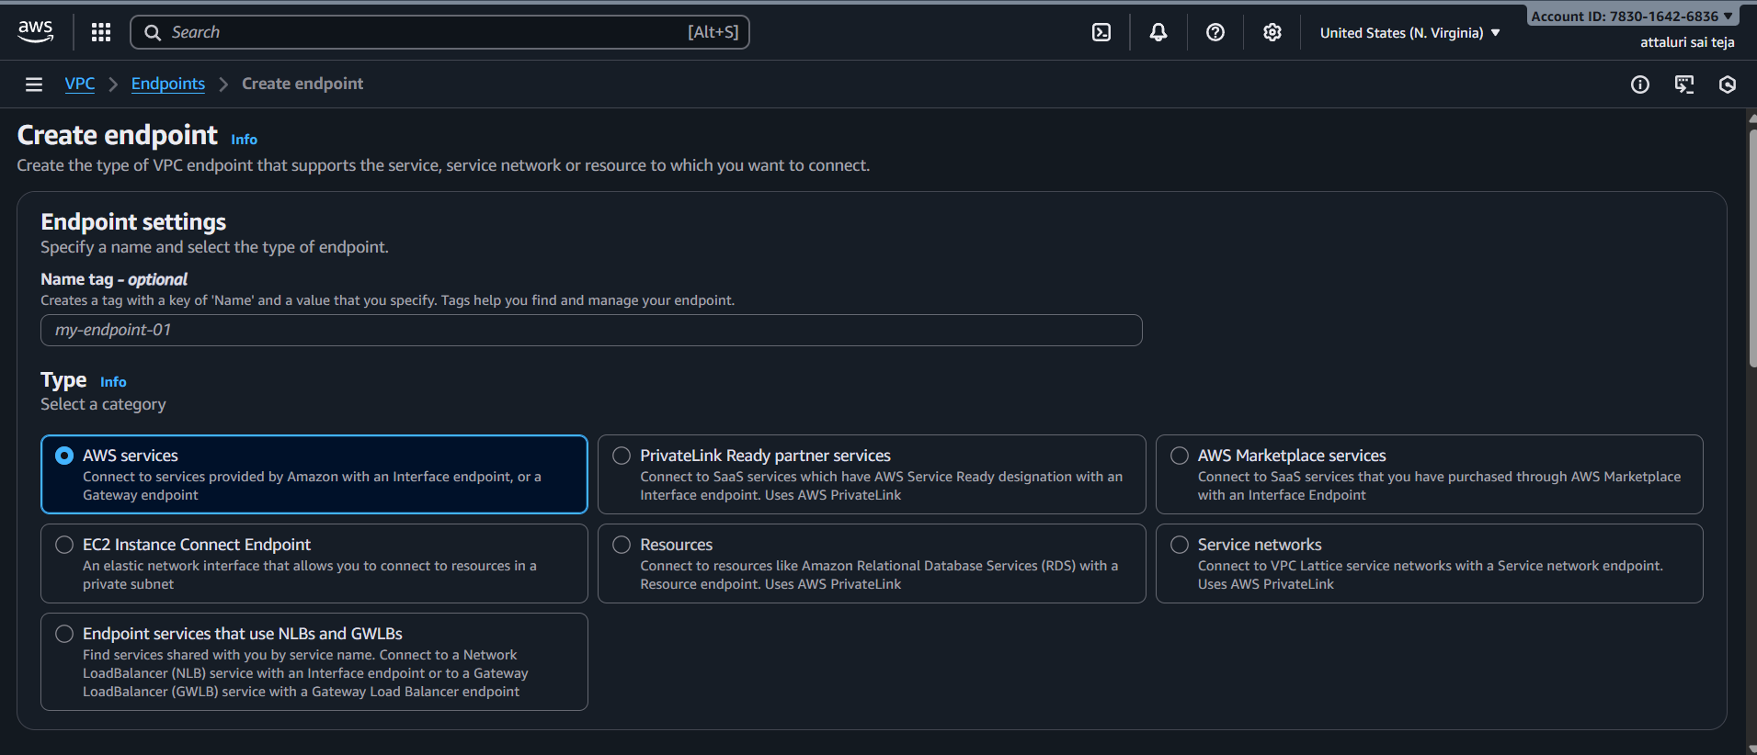
Step 5: Choose Service
- Select the AWS service for which you want to create a VPC Endpoint such as it can be any AWS Services like Amazon S3, AWS DynamoDB or others. Here we are choosing Amazon S3 in particular " com.amazonaws.us-east-1.s3 "
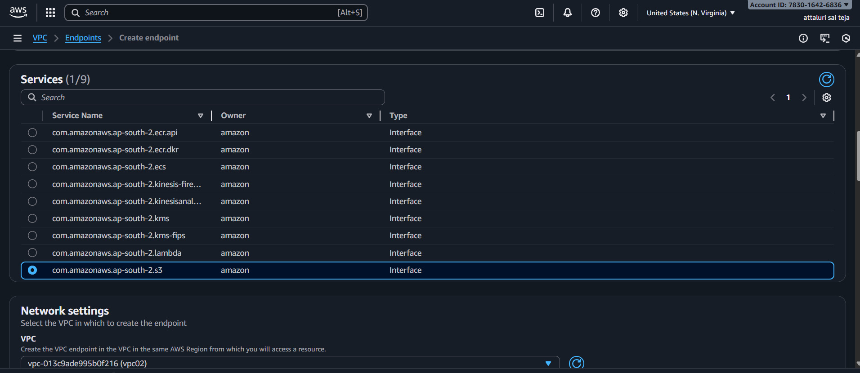

- Select the Vpc in network settings and enabled the DNS
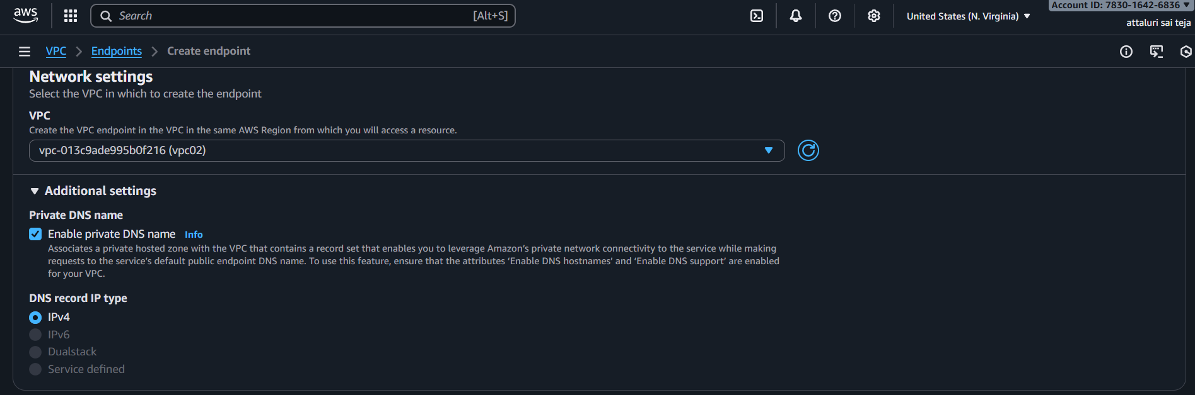
- Select the subnet and ip version
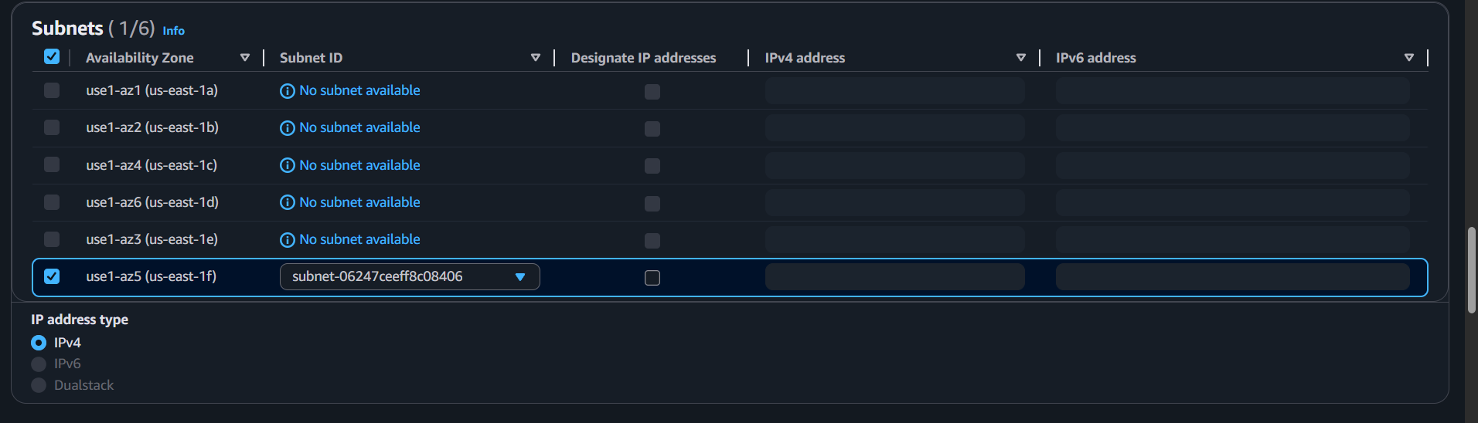
- Select the segurity groups as default and provide full access for policy section
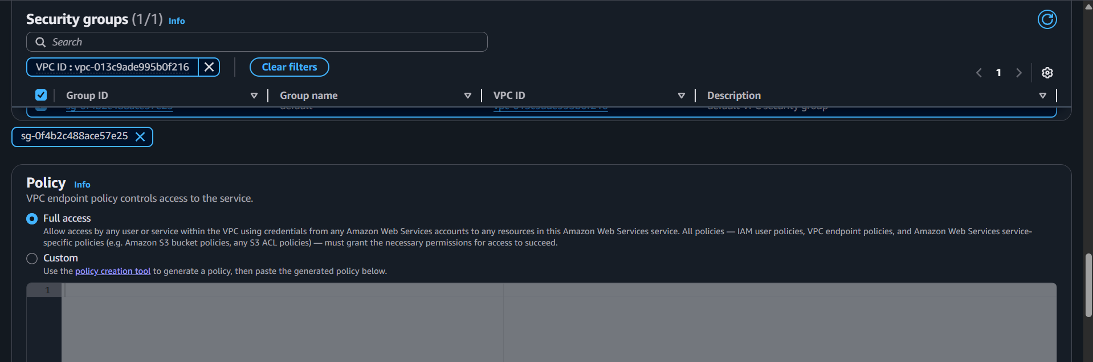

- Create End point by selecting the option
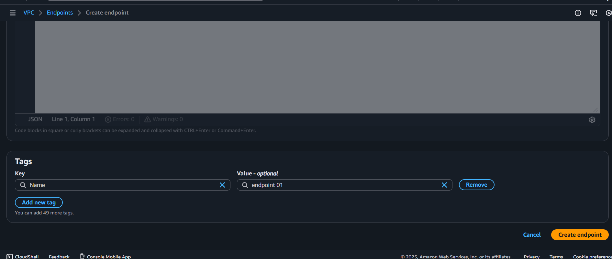
- Created END Point Successfully
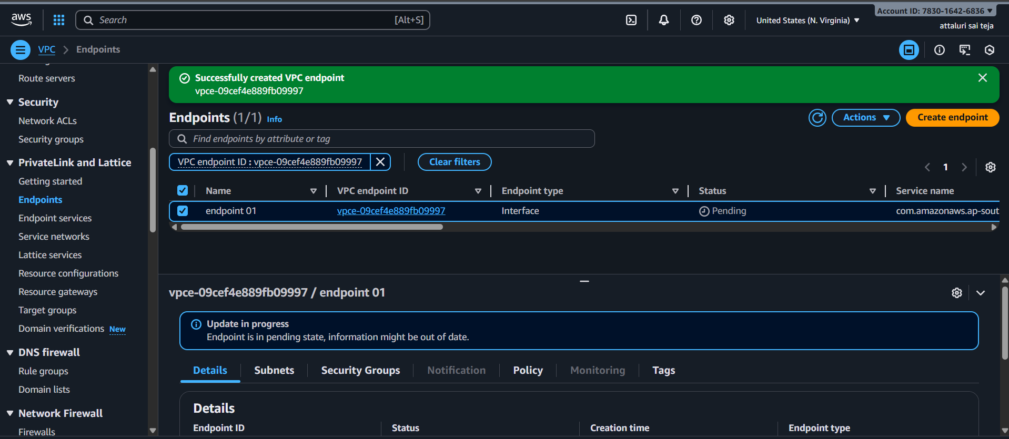
Verify Endpoint Creation
- Once the endpoint has created, verify its status in the Endpoints dashboard. It should shows as "Available" if the creation was successful.
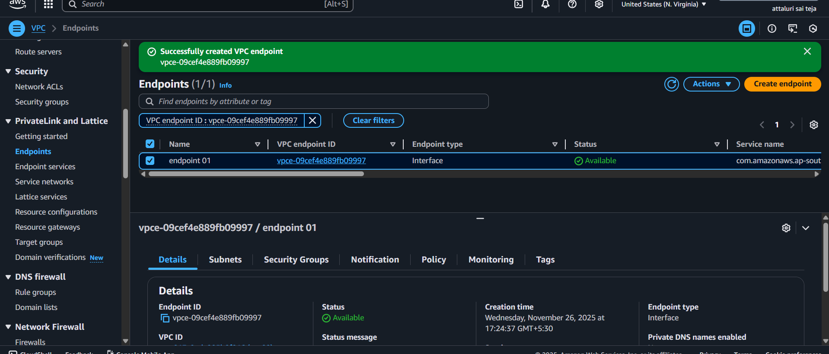
Create access key from security credentials
Paste it over in CLI using amazon configure
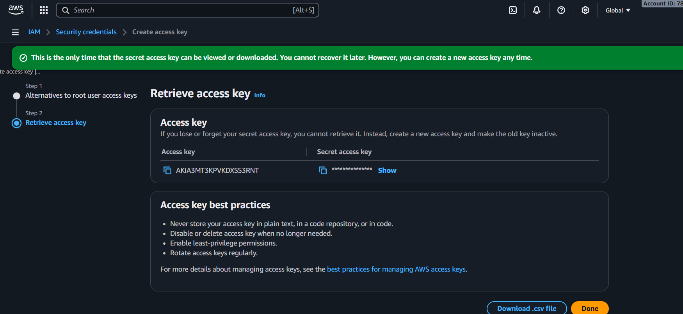
Creating a s3 bucket
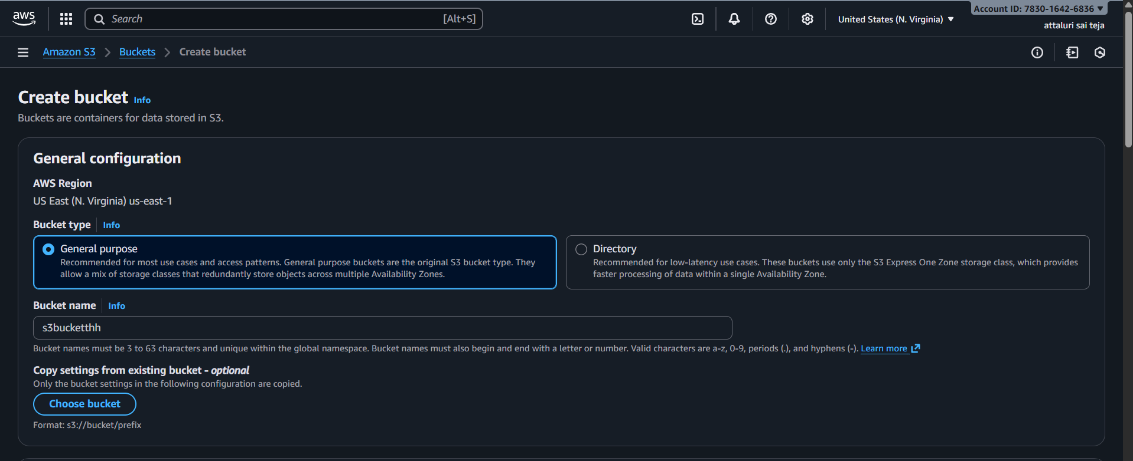

Bucket created
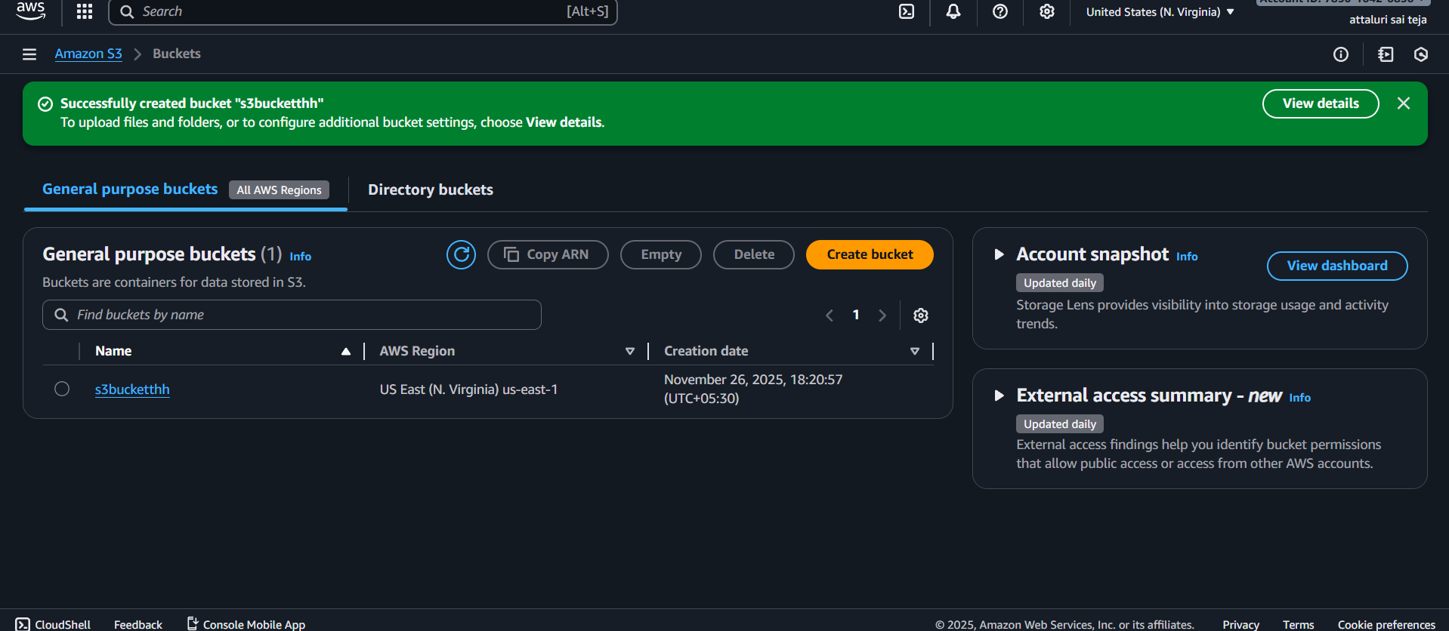
And do aws s3 ls for listing buckets
